Multi-Agent Insurance System Report

  - Course Name: Agentic AI
Institution Name: Medicaps University – Datagami Skill Based Course

Student Name(s) & Enrolment Number(s):
Sr no | Student Name | Enrolment Number
1 | ISHITA GARG | EN22CS301446
2 | ISHITA JAIN | EN22CS301447
3 | JANVI MAHAJAN | EN22CS301455
4 | JANAK DALKE | EN22CS301452

Group Name: Group 04D4
Project Number: AAI-40
Industry Mentor Name: Mr. Ashwin
University Mentor Name: Prof. Pradeep Baniya
Academic Year: 2026

Problem Statement & Objectives

Problem Statement

Traditional insurance systems often rely on manual processes or single AI models that handle all tasks together. This approach can lead to unstructured outputs, limited accuracy, and difficulty in handling complex queries.

There is a need for a system that can efficiently process insurance-related queries, retrieve relevant policy information, and generate clear, structured responses. The system should also support task division and collaboration to improve output quality.

Project Objectives

The main objectives of this project are:

To design a multi-agent system for handling insurance queries

To implement agent collaboration using Agentic AI concepts

To separate tasks into research and content generation

To generate structured and readable insurance reports

To demonstrate workflow orchestration using AI agents

Scope of the Project

The project focuses on building a system that:

Accepts user queries related to insurance policies

Retrieves relevant policy information using a Researcher Agent

Generates structured responses using a Writer Agent

Uses LLM APIs for reasoning and text generation

The system is limited to basic insurance query handling and response generation and does not include real-time policy databases or enterprise-level integrations.

Proposed Solution
- Key features
- Multi-agent architecture with specialized roles
- Task delegation using an Agent Orchestrator
- Separation of research and content generation
- Structured and readable output generation
- Integration with LLM API for intelligent responses

- Overall Architecture / Workflow
The system follows a structured workflow:
- The user submits a query through the interface
- The query is processed by the Agent Orchestrator
- The Researcher Agent collects relevant insurance information
- The Writer Agent synthesizes the information
- The final response is generated and displayed to the user
This workflow ensures efficient task handling and clear output generation.

- Tools & Technologies Used
- Python – core programming language
- Streamlit – user interface development
- LangChain – agent workflow and orchestration
- Grok API – language processing and response generation

Results & Output
- Screenshots / outputs
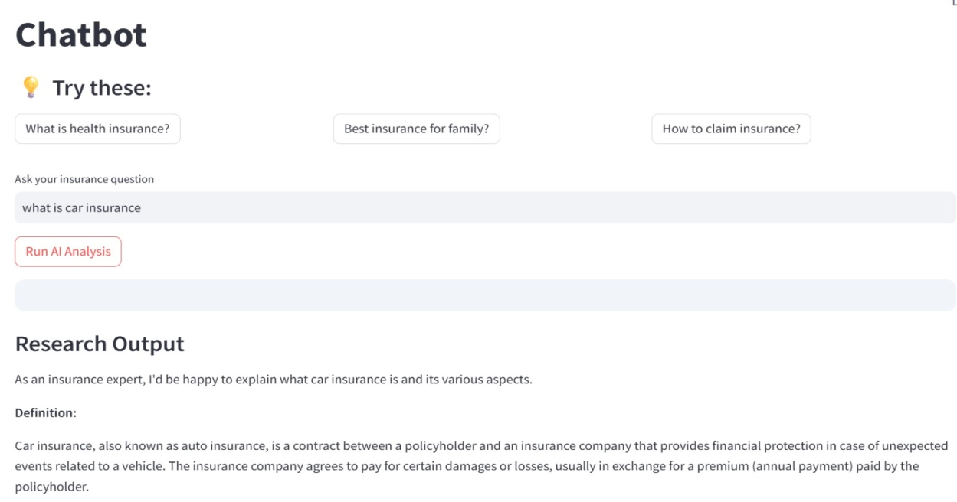

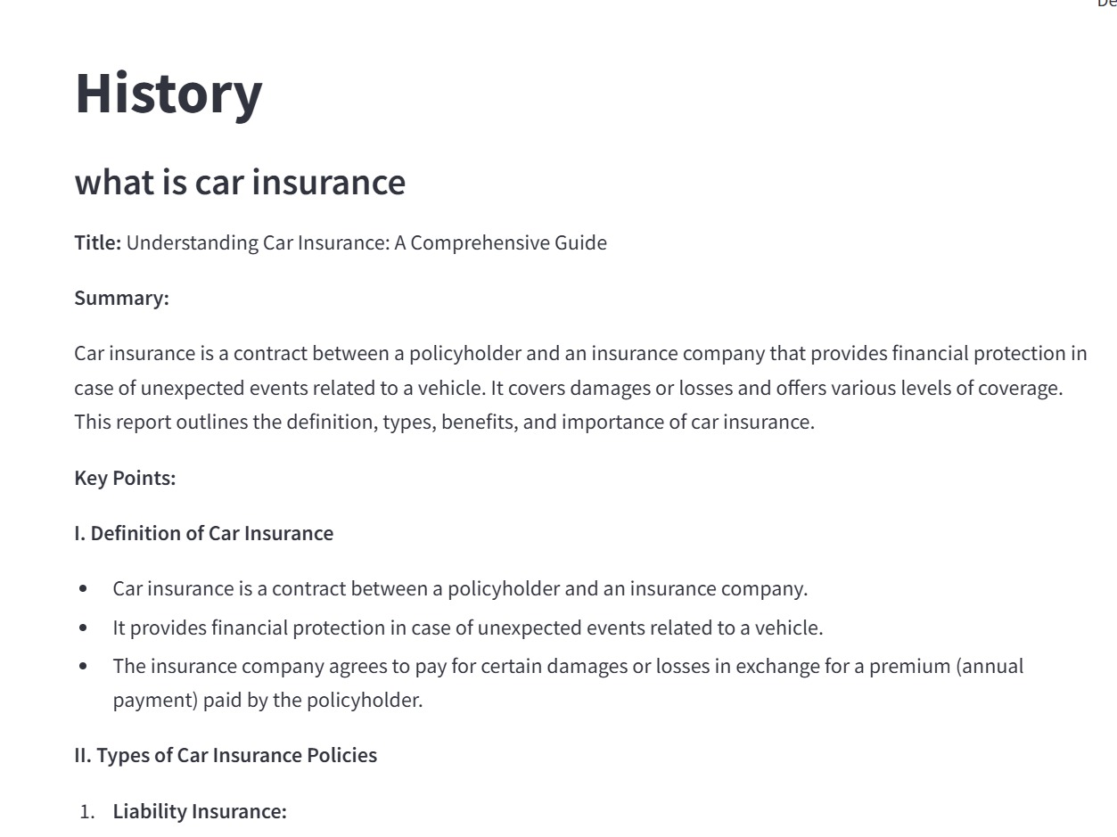

- Reports / dashboards / models
- Structured text-based insurance reports generated by the system
- No complex dashboards; output is focused on readable responses
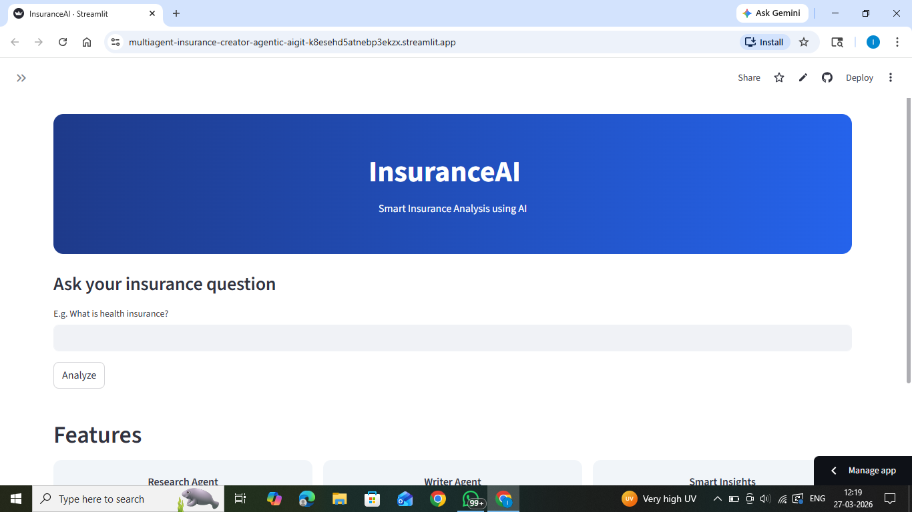
- Key outcomes
- Successful implementation of a multi-agent system
- Clear separation of responsibilities between agents
- Improved structure and readability of generated outputs
- Demonstration of Agentic AI workflow in a real-world use case

Conclusion

The Multi-Agent Insurance System demonstrates how Agentic AI can be used to solve complex tasks through collaboration between specialized agents. By dividing responsibilities between the Researcher Agent and Writer Agent, the system is able to generate structured and meaningful responses to insurance queries.

The project highlights the importance of modular design, workflow management, and effective use of AI models in building scalable and efficient applications.

Future Scope & Enhancements
The system can be further improved by:
- Adding more agents such as Validation Agent or Recommendation Agent
- Integrating real-time insurance databases
- Implementing a more advanced user interface
- Adding support for document upload and analysis

- Improving response accuracy using fine-tuned models
- Deploying the system as a scalable web application

